JAVA线程入门笔记

唐玖佳 2017年7月13日

理解线程
- 创建、停止线程
- 定义Thread的子类，提供run()方法的定义重写继承而来的方法。
- 把自己的类定义为实现了Runnable接口，这个接口声明了run()方法，之后再需要时在自己的类中创建Thread对象。
例：继承Thread类
import java.io.IOException;
/**
* Created by Administrator on 2016/7/13.
*/
public class TryThread extends Thread {
private String firstName;
private String secondName;
private long aWhile;
public TryThread(String firstName, String secondName, long delay) {
this.firstName = firstName;
this.secondName = secondName;
aWhile = delay;
setDaemon(true);//创建后台线程（Daemon Thread）:生命周朝决定于创建它的背景线程。不是后台的线程称为用户线程--必须被明确停止。
//只有在线程启动前才能调用setDaemon()方法。
}
public static void main(String[] args) {
Thread first = new TryThread("Tang", "Jiujia", 200L);
Thread second = new TryThread("Jiapi", "Tang", 300L);
Thread third = new TryThread("Wang", "Guolang", 500L);
System.out.println("Press enter when you have had engough...\n");
first.start();//start（）方法会启动run()方法，之后再返回给调用线程。
second.start();
third.start();
try {
System.in.read();//在按下回车之前，在main()调用的read（）方法将会被阻塞，但其他线程会继续执行。
System.out.println("Enter pressed...\n");
first.interrupt();//调用此方法，线程通知另一个线程停止执行。方法本身不会停止线程，只是通过在线程中设置标记请求中断
second.interrupt();//这些标记必须在run（）方法中检验才能起作用。sleep方法检查线程是否中断，如果已经中断，抛出
third.interrupt();//InterruptedException异常。注意与isInterruped（）实例方法，isAlive（）方法，和静态interrupted方法区别。
} catch (IOException e) {
System.out.println("Ending main()");
return;
}
}
@Override
public void run() {
try {
while (true) {
System.out.print(firstName);
sleep(aWhile);//sleep继承自Thread类，抛出InterruptedException异常。
System.out.print(secondName + "\n");
}
} catch (InterruptedException e) {
System.out.println(firstName + secondName + e);
}
}
}

（二）链接线程：

thread1.join(); //推迟当前线程直到thread1死掉。如果当前线程由另一个线程中断抛出InterruptedException.
Thread1.join(1000); //Wait up to one second for thread1 to die

- 线程的调度：
当仅仅希望其他线程在等待时有机会执行，而不希望当前线程的执行挂起指定时间，可以使用Thread的yield()方法。

（四）实现Runnable（）接口

import java.io.IOException;
/**
* Created by Administrator on 2016/7/14.
*/
public class JumbleNames implements Runnable {
private String firstName;
private String secondName;
private long aWhile;
public JumbleNames(String firstName,String secondName,long delay){
this.firstName=firstName;
this.secondName=secondName;
aWhile=delay;
}
public void run(){
try{
System.out.print(firstName);
Thread.sleep(aWhile);//静态方法
System.out.print(secondName);
}catch(InterruptedException e){
System.out.println(firstName+secondName+e);
}
}
public static void main(String[] args){
Thread first=new Thread(new JumbleNames("Tang","Jiapi",200L));//也可以为线程命名Thread first=new Thread(new JumbleNames("Hopalong","Cassidy",200L),"firstThread");
Thread second=new Thread(new JumbleNames("Jiapi","Tang",200L));
Thread third=new Thread(new JumbleNames("Wang","Guolang",200L));
first.setDaemon(true);
second.setDaemon(true);
third.setDaemon(true);
System.out.println("Press when you have had enough....\n");
first.start();
second.start();
third.start();
try{
System.in.read();
System.out.println("Enter pressed...\n");
}catch (IOException e){
System.err.println(e);
}
System.out.println("Ending main()");
return;
}
}

管理线程
- 同步
同步的目标是当多个线程希望访问同一资源时，确保在任意时刻只有一个线程可以访问。
1.同步方法
public class Myclass {
synchronized public void method1(){
//使用关键字synchronized使任意类中的方法子集或所有方法
//都是互斥的，即任意时刻只能执行其中的一个。
//同步过程利用每个对象都关联了内部锁。
}
synchronized public void method2(){
//只能同步方法中的一个，确保每个同步方法执行时独占对象访问权。
//但另一个线程任然可以调用另一个对象的相同方法。
}
public void method3(){}
}

使用同步方法：
创建Bank:
public class Bank {
public synchronized void doTransaction(Transaction transaction){
int balance=transaction.getAccount().getBalance();
switch (transaction.getTransactionType()){
case CREDIT:
try{
Thread.sleep(100);
}catch (InterruptedException e){
System.out.println(e);
}
balance+=transaction.getAmount();
break;
case DEBIT:
try{
Thread.sleep(150);
}catch(InterruptedException e){
System.out.println(e);
}
balance-=transaction.getAmount();
break;
default:
System.out.println("Invalid transaction");
System.exit(1);
}
transaction.getAccount().setBalance(balance);
}
}

创建Transaction
public class Transaction {
public Transaction(Account account,TransactionType type,int amount){
this.account=account;
this.type=type;
this.amount=amount;
}
public Account getAccount(){return account;}
public TransactionType getTransactionType(){return type;}
public int getAmount(){return amount;}
@Override
public String toString(){
return type+"A//C: "+account+" : $"+amount;
}
private Account account;
private int amount;
private TransactionType type;
}

TransactionType:
public enum TransactionType {
DEBIT,CREDIT
}

public class Account {
public Account(int accountNumber,int balance){
this.accountNumber=accountNumber;
this.balance=balance;
}
public int getBalance(){return balance;}
public void setBalance(int balance){this.balance=balance;}
public int getAccountNumber(){return accountNumber;}
@Override
public String toString(){
return "A/C No. "+accountNumber+" : $"+balance;
}
private int balance;
private int accountNumber;
}

public class Clerk implements Runnable {
private Bank theBank;
private Transaction inTray;
public Clerk(Bank theBank){
this.theBank=theBank;
inTray=null;
}
public void doTransaction(Transaction transaction){
inTray=transaction;
}
public void run(){
while (true){
while (inTray==null){
try{
Thread.sleep(150);
}catch (InterruptedException e){
System.out.println(e);
}
}
theBank.doTransaction(inTray);
inTray=null;
}
}
public Boolean isBusy(){
return inTray!=null;
}
}

import java.util.Random;
/**
* Created by Administrator on 2016/7/14.
*/
public class BankOperation {
public static void main(String[] args){
int initialBalance=500;
int totalCredits=0;
int totalDebits=0;
int transactionCount=20;
Bank theBank=new Bank();
Clerk clerk1=new Clerk(theBank);
Clerk clerk2=new Clerk(theBank);
Account account=new Account(1,initialBalance);
Thread clerk1Thread=new Thread(clerk1);
Thread clerk2Thread=new Thread(clerk2);
clerk1Thread.setDaemon(true);
clerk2Thread.setDaemon(true);
clerk1Thread.start();
clerk2Thread.start();
Random rand=new Random();
Transaction transaction;
int amount=0;
for(int i=1;i<=transactionCount;++i){
amount=50+rand.nextInt(26);
transaction=new Transaction(account,TransactionType.CREDIT,amount);
totalCredits+=amount;
while (clerk1.isBusy()){
try{
Thread.sleep(25);
}catch(InterruptedException e){
System.out.println(e);
}
}
clerk1.doTransaction(transaction);
amount=30+rand.nextInt(31);
transaction=new Transaction(account,TransactionType.DEBIT,amount);
totalDebits+=amount;
while (clerk2.isBusy()){
try{
Thread.sleep(25);
}catch (InterruptedException e){
System.out.println(e);
}
}
clerk2.doTransaction(transaction);
}
while(clerk1.isBusy()||clerk2.isBusy()){
try{
Thread.sleep(25);
}catch (InterruptedException e){
System.out.println(e);
}
}
System.out.println(
"Original balance :$"+initialBalance+"\n"+
"Total credits :$"+totalCredits+"\n"+
"Total debits :$"+totalDebits+"\n"+
"Total balance :$"+account.getBalance()+"\n"+
"Should be :$"+(initialBalance+totalCredits-totalDebits));
}
}

- 同步代码块
public class Bank {
// Perform a transaction
public void doTransaction(Transaction transaction) {
switch(transaction.getTransactionType()) { //synchronized关键字后面的圆括号中的表达式用来指定要同步的对象。一旦执行
case CREDIT: //到给定账户的同步代码块，就不能再执行为这个账户对象同步的其他代码块或方法。
synchronized(transaction.getAccount()) { //但可以执行其他对象的借款处理代码
System.out.println("Start credit of " +
transaction.getAccount() + " amount: " +
transaction.getAmount());
int balance = transaction.getAccount().getBalance();
try {
Thread.sleep(100);
} catch(InterruptedException e) {
System.out.println(e);
}
balance += transaction.getAmount();
transaction.getAccount().setBalance(balance);
System.out.println(" End credit of " +
transaction.getAccount() + " amount: " +
transaction.getAmount());
break;
}
case DEBIT:
synchronized(transaction.getAccount()) {
System.out.println("Start debit of " +
transaction.getAccount() + " amount: " +
transaction.getAmount());
int balance = transaction.getAccount().getBalance();
try {
Thread.sleep(150);
} catch(InterruptedException e) {
System.out.println(e);
}
balance -= transaction.getAmount();
transaction.getAccount().setBalance(balance);
System.out.println(" End debit of " +
transaction.getAccount() + " amount: " +
transaction.getAmount());
break;
}
default:
System.out.println("Invalid transaction");
System.exit(1);
}
}
}

import java.util.Random;
/**
* Created by Administrator on 2016/7/14.
*/
public class BankOperation2 {
public static void main(String[] args){
int[] initialBalance={500,800};
int[] totalCredits=new int[initialBalance.length];
int[] totalDebits=new int[initialBalance.length];
int transactionCount=20;
Bank theBank=new Bank();
Clerk clerk1=new Clerk(theBank);
Clerk clerk2=new Clerk(theBank);
Account[] accounts=new Account[initialBalance.length];
for(int i=0;i<initialBalance.length;++i){
accounts[i]=new Account(i+1,initialBalance[i]);
totalCredits[i]=totalDebits[i]=0;
}
Thread clerk1Thread=new Thread(clerk1);
Thread clerk2Thread=new Thread(clerk2);
clerk1Thread.setDaemon(true);
clerk2Thread.setDaemon(true);
clerk1Thread.start();
clerk2Thread.start();
Random rand=new Random();
Transaction transaction;
int amount=0;
int select=0;
for(int i=1;i<=transactionCount;++i){
select=rand.nextInt(accounts.length);
amount=50+rand.nextInt(26);
transaction=new Transaction(accounts[select],TransactionType.CREDIT,amount);
totalCredits[select]+=amount;
while (clerk1.isBusy()){
try{
Thread.sleep(25);
}catch(InterruptedException e){
System.out.println(e);
}
}
clerk1.doTransaction(transaction);
select=rand.nextInt(accounts.length);
amount=30+rand.nextInt(31);
transaction=new Transaction(accounts[select],TransactionType.DEBIT,amount);
totalDebits[select]+=amount;
while (clerk2.isBusy()){
try{
Thread.sleep(25);
}catch (InterruptedException e){
System.out.println(e);
}
}
clerk2.doTransaction(transaction);
}
while(clerk1.isBusy() || clerk2.isBusy()) {
try {
Thread.sleep(25);
} catch(InterruptedException e) {
System.out.println(e);
}
}
for(int i = 0; i < accounts.length; ++i) {
System.out.println("Account Number:"+accounts[i].getAccountNumber()+"\n"+
"Original balance : $" + initialBalance[i] + "\n" +
"Total credits : $" + totalCredits[i] + "\n" +
"Total debits : $" + totalDebits[i] + "\n" +
"Final balance : $" + accounts[i].getBalance() + "\n" +
"Should be : $" + (initialBalance[i]
+ totalCredits[i]
- totalDebits[i]) + "\n");
}
}
}

- 死锁

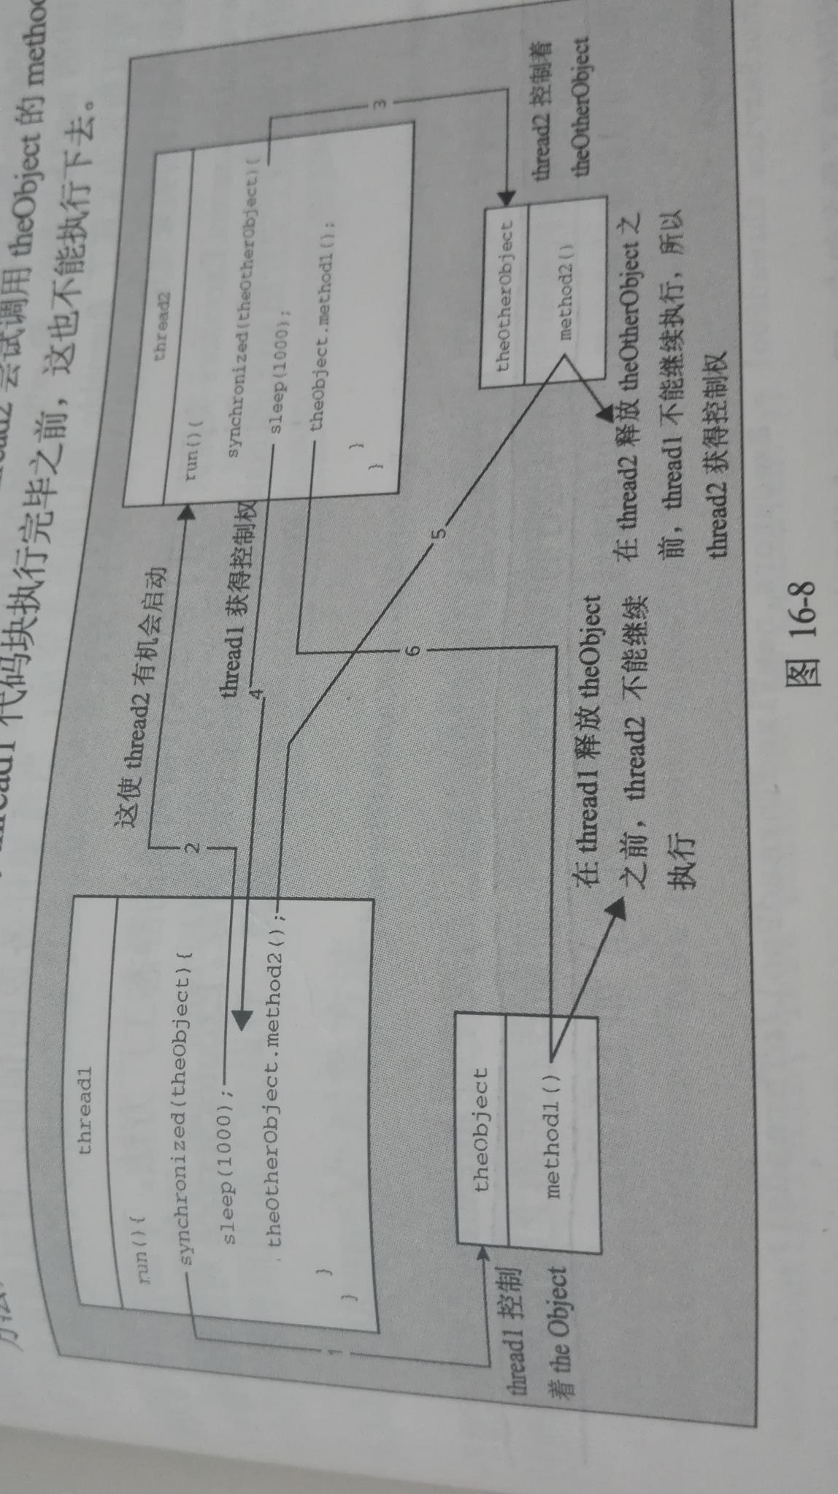

- 使用执行器
1.Callable<>接口：此接口必须实现Callable<>接口，接口声明了call()方法，此方法与ran()类似但call在终止时返回值。
2.创建执行器的静态工厂方法：
import java.util.concurrent.ExecutorService;
import java.util.concurrent.Executors;
ExecutorService threadPool= Executors.newCachedThreadPool();//创建新线程，每次使用threadPool对象启动新任务，都会使用线程池中当前不再运行的现有线程，或者创建新线程并将之添加到线程池中。
int nThreads=5;
ExecutorService threadPool=Executors.newFixedThreadPool(nThreads);//限制可以创建的线程数。如果线程池中的所有线程都已经分配了任务就对新线程排队，等到其中一个现有线程空闲为止。关闭threadPool以后，线程池中所有的线程任然继续存在。如果最大线程小于1，抛出IllegalArgumentException.
ExecutorService是接口类型由java.util.concurrent包中的一些类进行了实现。前面介绍的Executor类中的两个方法都返回ThreadPoolExecutor类型的对象引用，功能由ExecutorService接口描述。

- 使用执行器
由ExecutorService接口指定的方法可以提交要在新线程或线程池的现有空闲线程中执行的新任务。
Future<?> future=threadPool.submit(clerk1);//这段代码启动了Runnable任务clerkl。submit()方法返回java.util.concurrent.Future<V>类型引用，从而反映任务在任意时刻的状态，并最终封装执行任务的结果，结果的类型是V。Runnable任务不返回结果，故submit()方法返回值是Future<?>类型。Runnable任务的第二个submit()方法接收的第二个参数是V类型，指定任务完成时返回的结果，这样可确保指定结果由Future<V>封装。

4执行Callable<V>任务
Future<String> future=threadPool.submit(callabeTask);//如果任务参数是null，submit所有版本抛出NullPointerException如果任务因为某种原因不能执行，抛出java.util.concurrent.RejectedExecutionException类型异常。

- Future<V>对象方法

Future<String> future=threadPool.submit(callabeTask);//submit()方法返回的Future<>引用会在任务执行完毕之前返回，因此Future<>对象提供了一种方式来访问正在执行的任务并确定任务的状态。
if(future.cancel(ture)){
System.out.println("Task has been cancelled."); //}else{
System.out.println("Task could not be cancelled.");
}//如果任务不能被取消，返回false。isCancelled()方法可以判定任务是否被取消。
String result=null;
try{
result=future.get();
}catch(CancellationException e){
System.out.println("Task has been cancelled before a result was obtained.");
}catch(InterruptedException e){
System.out.println("Current thread was interrupted while awaiting a result.");
}catch(ExecutionException e){
System.out.println("Task threw a exception");
Throwable casuse=e.getCause();
if(casuse==null){
System.out.println("Cause could not be determined");
}else{
System.out.println(casuse);
}
}

- 关闭线程池
threadPool.shutdown();//启动关闭线程的过程
try{
if(threadPool.awaitTermination(100L,TimeUnit.MILLISECONDS)){//线程池中的任务完成后再关闭线程池，如果在时间内没完成返回false。
System.out.println("All tasks to completed.");
}else {System.out.println("Tasks failed to complete");}
}catch(InterruptedException e){
System.out.println("Current thread interrupted awaiting termination.");
}
List<Runnable> tasks=threadPool.shutdownNow();//此方法可以关闭线程池中的任务，方法为每个线程调用interrupt()方法来取消正在运行的任务，所以线程池中没有响应中断的任务不会关闭。返回的列表包含在线程中执行关闭操作时正等待开始执行的任务。
//通过调用ExecutorService对象的isTerminated()方法，可以测试线程池中的所有任务是否关闭。如果调用了shutdown()或shutdownNow()方法且所有的任务都结束，方法返回true。如果执行器被关闭，isShutdown()方法就返回true。

- 线程优先级

